Professional Tree Care Services

Table of Contents
Professional Tree Care Services in Edmonton 2
Comprehensive Tree Services 3
Tree Health Assessment and Treatment 3
Emergency Tree Services 4
Certified Arborists You Can Trust 4
Customer Satisfaction Guaranteed 4
Contact Us Today 5
FAQs 5
1. What services do trustworthy Edmonton arborists provide? 5
2. How can I find a reliable arborist in Edmonton? 5
3. Are tree care services expensive? 5
4. How often should I schedule tree maintenance? 6
5. Can arborists help with tree emergencies? 6

we understand the significance of trees in enhancing the beauty and environmental sustainability of your property in edmonton arborists. With our team of highly skilled and certified arborists, we offer comprehensive tree care services to meet all your needs. Whether you require tree pruning, removal, stump grinding, or emergency tree care, we are here to provide you with top-notch solutions.

Professional Tree Care Services in Edmonton
At Edmonton Arbor Care, we understand the importance of maintaining healthy tree care winnipeg arborists to enhance the beauty and safety of your property. With years of experience serving residential and commercial clients in Edmonton and surrounding areas, we take pride in being your trusted partner for all your tree care needs.
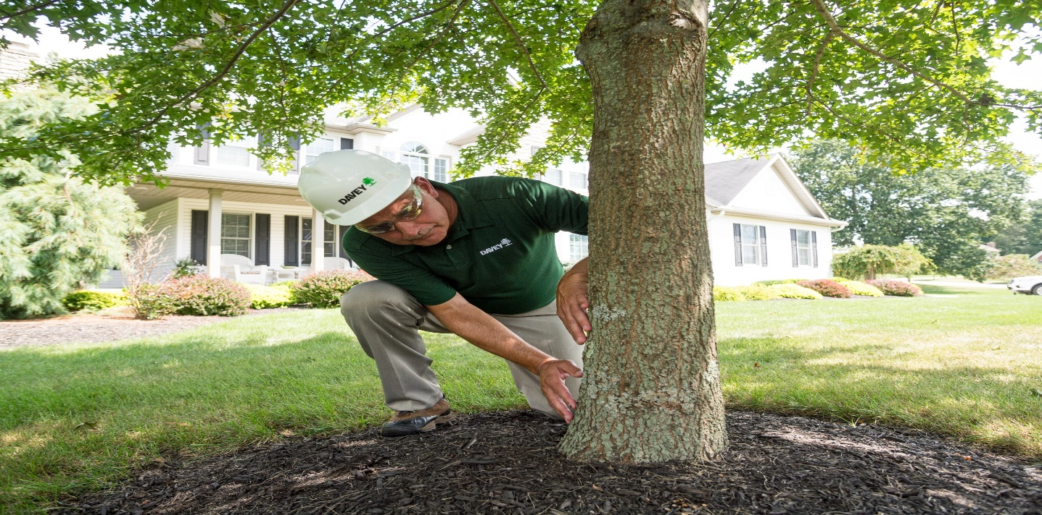

Comprehensive Tree Services
Our team of certified arborists is dedicated to providing top-quality tree services to help you maintain beautiful, healthy trees year-round. Whether you need routine tree trimming and pruning to promote optimal growth or tree removal and stump grinding to eliminate hazardous trees, we have the skills and expertise to get the job done safely and efficiently.

Tree Health Assessment and Treatment
Trees are valuable assets that require regular care and attention to thrive. Our arborists specialize in tree health assessment and disease diagnosis, utilizing advanced techniques and tools to identify potential issues and develop effective treatment plans. Importance of Tree Doctor from pest infestations to fungal infections, we'll work diligently to restore your trees to their full health and vitality.

Emergency Tree Services
Tree emergencies can occur unexpectedly, posing risks to your property and safety. That's why we offer 24/7 emergency tree services to respond promptly to urgent situations such as storm damage, fallen trees, and hazardous limbs. Our skilled arborists are equipped with the necessary tools and equipment to handle emergency tree situations with precision and care.

Certified Arborists You Can Trust
When it comes to tree care, trust matters. Our team of certified arborists undergoes rigorous training and certification to ensure the highest standards of professionalism, safety, transforming and expertise. We adhere to industry best practices and use state-of-the-art equipment to deliver superior results and exceed your expectations.
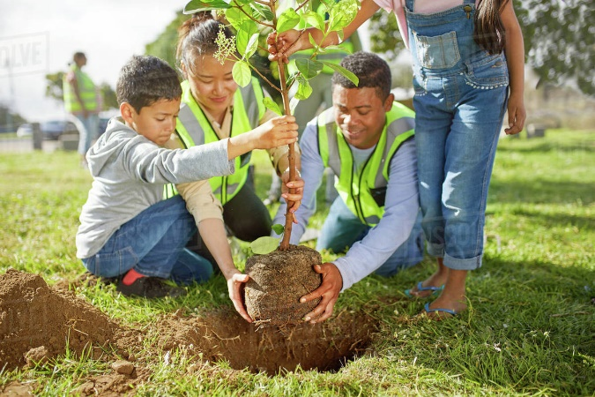 | 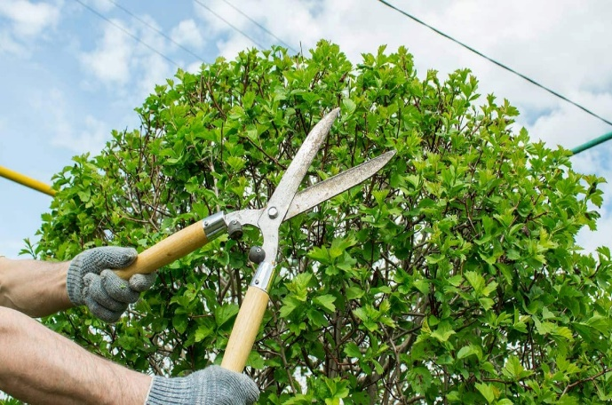

Customer Satisfaction Guaranteed
At Edmonton Arbor Care, customer satisfaction is our top priority. From the initial consultation to the completion of the project, we strive to provide exceptional service and personalized attention to every client.
We'll work closely with you to understand your needs, address any concerns, and ensure that you're completely satisfied with the results.

Contact Us Today
Ready to experience the difference that professional tree care services can make for your property? Contact Edmonton Arbor Care today to schedule a consultation with one of our knowledgeable arborists. Let us help you maintain healthy, beautiful trees that enhance the value and appeal of your landscape.

FAQs

1. What services do trustworthy Edmonton arborists provide?
Trustworthy Edmonton arborists offer a comprehensive range of tree care services, including tree trimming, pruning, tree removal, stump grinding, tree health assessment, and disease treatment. Whether you need routine maintenance or emergency tree services, these professionals are equipped to handle all your arboricultural needs.

2. How can I find a reliable arborist in Edmonton?
Finding a reliable arborist in Edmonton can be challenging, but there are a few key factors to consider. Look for arborists who are certified by reputable organizations such as the International Society of Arboriculture (ISA) or the Tree Care Industry Association (TCIA). Additionally, read online reviews and ask for references to ensure you're hiring a trustworthy professional with a proven track record of quality service.

3. Are tree care services expensive?
The cost of tree care services can vary depending on the scope of work required, the size and condition of the trees, and the expertise of the arborist. While some tree care services may seem expensive upfront, investing in professional arboricultural services can ultimately save you money by preventing property damage and preserving the health of your trees in the long run.

4. How often should I schedule tree maintenance?
The frequency of tree maintenance depends on various factors, including the species of trees, environmental conditions, and previous maintenance history. A qualified arborist can assess your trees and recommend an appropriate maintenance schedule tailored to your specific needs.

5. Can arborists help with tree emergencies?
Yes, reputable arborists in Edmonton are available to assist with tree emergencies such as storm damage, fallen trees, and hazardous limbs. These professionals have the necessary training, equipment, and expertise to safely address emergency situations and minimize further damage to your property.

